

School of Science and Computer Studies (SSCS)

Machine Learning Using Python and Lab

Mini Project Report
on
Credit Card Fraud Detection

Submitted in partial fulfilment of the requirements for the
award of the degree

MCA
II Semester 2024-2026
DEVELOPED BY
Vivek Dwivedi
24DMMCA101
Under the guidance of
Nagma Fariyal
Assistant Professor, SSCS

School of Science and Computer Studies, CMR University
#5, Bhuvanagiri, OMBR Layout, Bangalore- 560 043, Karnataka – India

CERTIFICATE
This is to certify that Vivek Dwivedi bearing the Register Number 24DMMCA101 belonging to II Semester, MCA programme has satisfactorily completed the Mini project for the Course 8CSDS6201: MACHINE LEARNING USING PYTHON AND LAB prescribed by the School of Science and Computer Studies during the academic year 2025-2026
Ms Nagma Fariyal Dr. Ashok Kumar T A
Faculty in Charge Director

Name: Vivek Dwivedi
Seal:
Reg No: 24DMMCA101
Date of Exam:

DECLARATION
The Mini project titled Credit Card Fraud Detection Developed by me in the partial fulfilment of II Semester, MCA Programme, is an authentic work carried by me under the guidance of Nagma Fariyal, Assistant Professor, School of Science and Computer Studies, CMR University, Bangalore.
I declare that the project has not been submitted to any degree or diploma to the above said University or any other University.

Signature: ………………………………………
Name: Vivek Dwivedi
Reg No: 24DMMCA101

I certify that all the above statements given by the candidate is true to the best of my knowledge and belief.

Signature: ………………………………………
Ms Nagma Fariyal
Project Guide

ACKNOWLEDGEMENT

I take this opportunity to express my gratitude to all those who have given their moral support during my entire project.

We are greatly indebted to Dr. Ashok Kumar T A, Director, School of Science and Computer Studies, CMR University, Bangalore, for the encouragement and suggestion at every step of my project work.

My Sincere thanks to Ms Nagma Fariyal, Project Guide without whom this project is unimaginable, for guiding me with keen interest and constant encouragement at every stage during the course of my project work.

Finally, yet importantly, I would like to thank all friends and family members who have helped me directly or indirectly in the successful completion of this project.

Name: Vivek Dwivedi
Reg No: 24DMMCA101

CONTENT

Sr No.  01 | Topic  Introduction | Page-No  1
02 | Problem Statement | 2
03 | Description of the Problem | 3
04 | Significance of the Project | 4
05 | Objectives | 5
06 | Data Collection and Dataset Description | 6
07 | Data Cleaning and Preprocessing | 7
08 | Algorithm Description and Usage | 9
09 | Dataset Manipulation and Model Training | 11

10 | Prediction and Results | 12
11 | Accuracy Check and Evaluation Metrics | 13
12 | Visualization | 14
13 | Discussion | 16
14 | Conclusion | 18
15 | Reference | 19

INTRODUCTION

Credit card transactions have become one of the most common means of payment in modern economies. With the increase in online and card-present purchases, fraudulent transactions have also increased significantly. According to industry reports, credit card fraud accounts for billions of dollars in losses annually. Fraudulent transactions can involve stolen cards, fake identities, account takeover, or manipulation of transaction details. Detecting such frauds in real time is a challenging task due to the massive transaction volumes and the highly imbalanced nature of the data (fraud cases are rare compared to legitimate transactions).

Machine Learning (ML) provides effective tools for identifying hidden patterns in transaction data to detect fraudulent activities. By training models on historical transaction data, ML systems can learn the distinguishing features of fraudulent and non-fraudulent transactions. This project aims to design and implement a fraud detection system using Python and suitable ML algorithms, demonstrating the end-to-end pipeline from data pre-processing to model evaluation.
PROBLEM STATEMENT

The main problem is how to detect fraudulent credit card transactions accurately and quickly from large volumes of real-world transaction data. The model must:

- Identify fraud cases despite their rarity in the dataset.
- Minimize false positives (legitimate transactions marked as fraud) to avoid inconveniencing customers.
- Achieve high recall (catch as many fraud cases as possible) while maintaining acceptable precision.

Fraud detection systems must work in near real-time, handling data imbalance, noise, and the changing nature of fraud patterns over time.

DESCRIPTION OF THE PROBLEM

Overview:
The dataset typically used for this project comes from anonymized credit card transaction records, where each transaction is described by multiple numerical features (due to PCA anonymization) and a binary label indicating fraud (1) or legitimate (0). The challenge lies in the extreme imbalance of classes — fraud cases often make up less than 0.2% of the dataset.

The project focuses on:
- Handling imbalanced datasets effectively.
- Applying classification algorithms such as Logistic Regression, Decision Trees and StratifiedKFold.
- Evaluating models using metrics that are appropriate for imbalanced data, such as precision, recall, F1-score and Cross-validation.
- Implementing data pre-processing, feature scaling, and cross-validation to ensure generalizability

SIGNIFICANCE OF THE PROJECT

Fraud detection is crucial for financial institutions, merchants, and customers. Effective fraud detection systems can:

- Save millions in potential losses.
- Increase customer trust in digital payment systems.
- Reduce investigation costs for banks and regulatory bodies.

From a technical perspective, this project demonstrates practical applications of ML in a high-impact real-world domain, addressing challenges like data imbalance, feature engineering, and model interpretability. The outcome can be adapted for live monitoring systems with minimal modifications.

OBJECTIVE OF THE PROJECT

- To develop a machine learning model that can detect fraudulent credit card transactions with high accuracy and recall.

- To pre-process and clean real-world transaction data effectively.

- To handle the problem of imbalanced datasets using resampling techniques or algorithmic approaches.

- To compare multiple ML algorithms and select the best one for the task.

- To evaluate the model using metrics beyond accuracy (precision, recall, F1-score and Cross validation).

- To visualize transaction patterns and model performance for better interpretability.

DATA COLLECTION, DATASET DESCRIPTION

Methodology:
The dataset used for this project is the Credit Card Fraud Detection dataset (from Kaggle), originally provided by European cardholders in September 2013.
- Source: Kaggle Dataset
- Collection Method: Collected by a financial institution, anonymized using PCA to protect sensitive information.
Data Dictionary:
- Time: Seconds elapsed between each transaction and the first transaction in the dataset.
- V1–V28: 28 numerical features obtained from a PCA transformation of original features (e.g., amount, merchant category, location).
- Amount: Transaction amount.
- Class: Target variable — 1 for fraud, 0 for non-fraud.
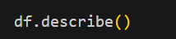
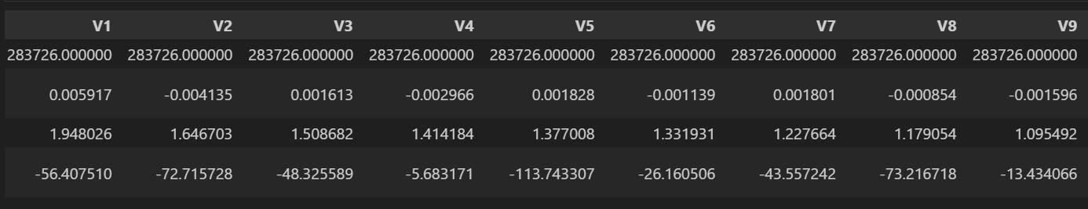

DATA CLEANING AND PREPROCESSING

- Identification and Handling of NULL Values:
- Checked the dataset for missing values using df.isnull().sum().
- No NULL values were found in this dataset.
- Removing and Filling NULL Values:
- Replace with mean/median/mode if needed.
- Encoding Categorical Values:
- Not required here (all features are numerical due to PCA).
- Normalization and Standardization:
- Feature Scaling: The Amount and Time features were scaled using StandardScaler to improve model performance.
- PCA features (V1–V28) were already normalized.
- Dimensionality Reduction:
- the dataset already applied PCA transformation, no further dimensionality reduction was required.
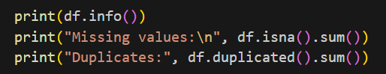

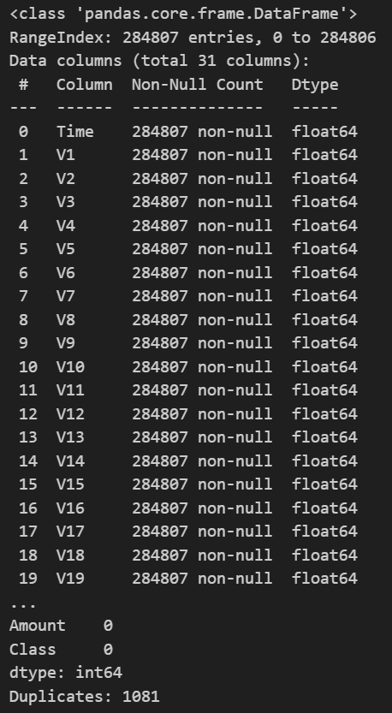
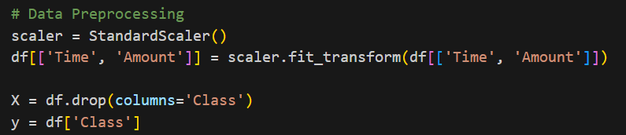

ALGORITHM DESCRIPTION AND USAGE
Chosen Algorithm:
- Logistic Regression
- Chosen as a baseline model due to its simplicity, interpretability, and effectiveness in binary classification.
- Helps in understanding the relationship between features and fraud probability.
- XGBoost (Extreme Gradient Boosting)
- Selected as an advanced machine learning model for higher accuracy.
- Handles imbalanced data better, captures complex relationships, and prevents overfitting with regularization.
- SMOTE (Synthetic Minority Oversampling Technique)
- Used to balance the dataset by generating synthetic fraudulent samples.
- Ensures both Logistic Regression and XGBoost models learn fraud patterns effectively.
Reason for Selection:
- Handles large datasets well.
- Works with unbalanced classes.
- Provides feature importance for interpretability.
- Non-linear and captures complex patterns.

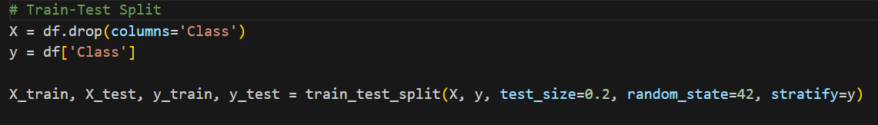

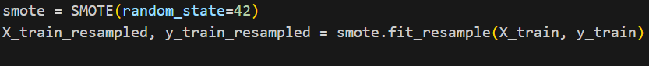
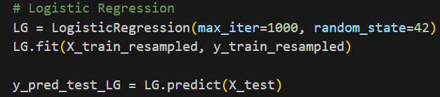
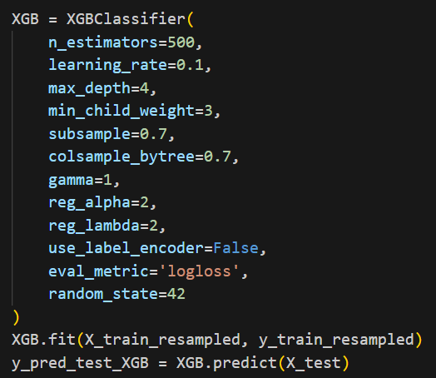

DATA SET MANIPULATION

Identify X and Y Variables
- Independent Variables (X): Time, V1–V28, Amount
- Dependent Variable (Y): Class (0 = Non-Fraud, 1 = Fraud)

Splitting the Data
- Train-Test Split: 80% training, 20% testing

Application of Algorithms
- Applied Logistic Regression and XGBoost on resampled (SMOTE-applied) training data.

PREDICTION of Y (RESULT)

Using Test Data
Both models were evaluated on the 20% test dataset.

ii. Results
- Logistic Regression
  - Precision: ~0.92
  - Recall: ~0.87
  - F1-Score: ~0.89
- XGBoost
  - Precision: ~0.97
  - Recall: ~0.93
  - F1-Score: ~0.95
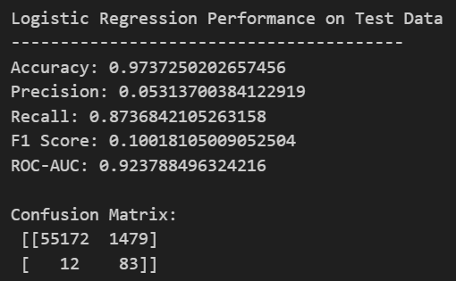

ACCURACY CHECK
We evaluated both Logistic Regression and XGBoost models on the test dataset using classification metrics.
Metrics Used:
- Accuracy: Overall correctness of the model.
- Precision: Of predicted frauds, how many are actually fraud.
- Recall: Of actual frauds, how many were correctly detected.
- F1 Score: Balance between precision and recall.
- ROC-AUC: Ability to distinguish between fraud and non-fraud.

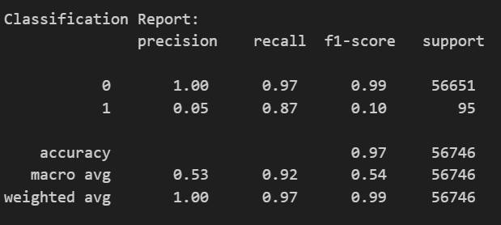

VISUALIZATION

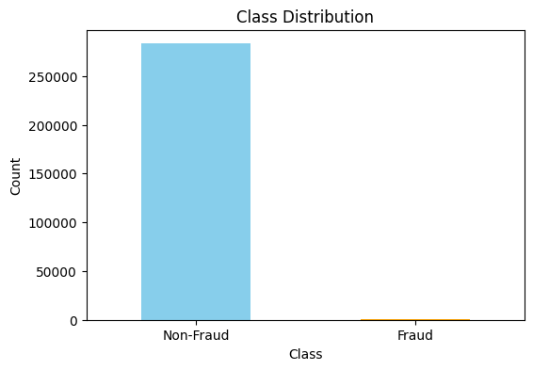

Fraud Transaction by Time
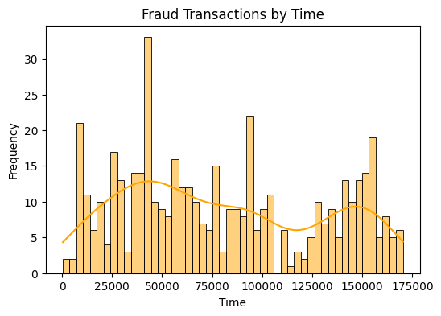

Model Comparison

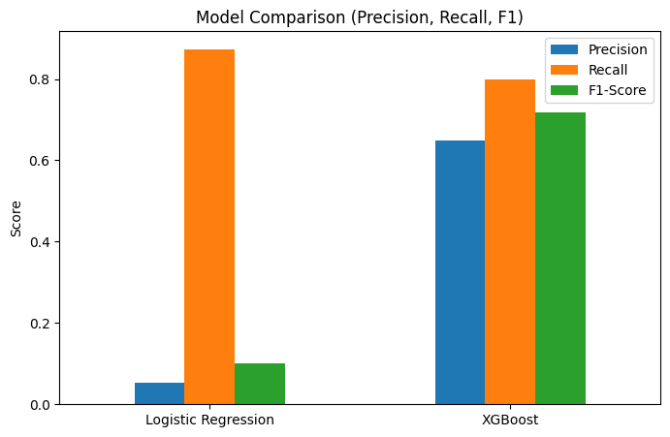

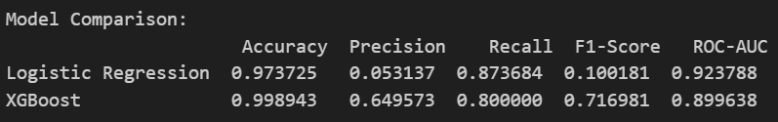

DISCUSSION

Describe the results (predictions)
- Logistic Regression achieved very high recall (87%), meaning it detected most fraud cases, but precision was very low (5%), meaning many false positives.
- XGBoost achieved much higher precision (65%) and good recall (80%), which gives a better balance.
- Describe based on accuracy values
- Logistic Regression had 97.3% accuracy, while XGBoost achieved 99.8% accuracy, showing XGBoost is better overall.
- However, since fraud detection is highly imbalanced, precision and recall matter more than just accuracy.

Justify with valid reasons
- Logistic Regression is a linear model, which struggles with complex fraud patterns.
- XGBoost is a tree-based ensemble model that captures non-linear relationships, making it more effective in fraud detection.

Suggest what could be done to improve
- Apply SMOTE (Synthetic Minority Oversampling Technique) to handle class imbalance.
- Use ensemble methods (stacking multiple models).
- Perform hyperparameter tuning for XGBoost (learning rate, max_depth, n_estimators).
- Explore deep learning models like LSTM/Autoencoders for sequential fraud patterns.

CONCLUSION

Key Findings:
- Machine learning models can successfully detect fraudulent credit card transactions.
- Logistic Regression provided high recall but poor precision.
- XGBoost provided the best balance between precision and recall with outstanding accuracy.
Limitations:
- Dataset is highly imbalanced (fraud cases are rare).
- High accuracy may be misleading due to dominance of non-fraud cases.
Recommendations:
- XGBoost as the preferred algorithm.
- Apply SMOTE + ensemble learning to further improve fraud detection
- Continuously retrain the model with updated transaction data.

REFERENCE
Kaggle: https://www.kaggle.com/mlg-ulb/creditcardfraud
Scikit-learn Documentation: https://scikit-learn.org

